 | Data submission tool and data distribution tool User ManuaL
1/12/2017 | https://ais.lgs.lv

Content
1. ABOUT 2
2. Registration and Login 3
2.1 Registration 3
2.2 Login 4
3. File exchange and CRC32Q value with/without JAVA APPLET 6
3.1 Managing JAVA Applet option in USER PROFILE 6
3.2 File exchange without JAVA 7
3.3 File exchange with JAVA 8
3.3.1 JAVA applet upload in Microsoft INTERNET EXPLORER 9
3.3.2 JAVA applet upload in mozilla Firefox 10
3.4 Checking FILE CRC32Q value when JAVA disabled 11
3.4.1 Via actions: Check file CRC32Q value 11
3.4.2 Via CRC32Q value checker program 13
4. Data/information submisstion tool 16
4.1 Actions: Add new request 16
4.1.1 Data submisstion for request types: AIP AMDT, AIP SUP AND AIC 17
4.1.2 Data submisstion for Notam request type 19
4.1.3 Metadata submission for all request types 21
4.1.4 Request processing statuses 22
4.1.5 Request change history 23
4.2 Search registered requests 24
4.3 Edit AIP AMDT, AIP SUP AND AIC registered requests 25
5. Data distribution tool 27
5.1 File Download from Data distribution tool 27
5.1.1 File download without JAVA 27
5.1.2 File download with JAVA 30

ABOUT
Aeronautical Information Service (AIS) of Latvia website provides tools for Data/information submission and Data distribution of aeronautical information concerning the entire territory of the Republic of Latvia and the relevant airspace.
Data/information submission tool is designed to be used by the clients who have a signed formal arrangement with AIS of Latvia on data/information submission and who are approved as data originators. This tool have an integrated JAVA applet that performs integrity check (by implementing CRC32Q algorithm) of files during the file download or upload process.
Data distribution tool provides data distribution services such as eTOD or eAIP provision. Through this tool the Aeronautical Information Service has granted to its clients (users) access to the distributed information. This tool also have an integrated JAVA applet that performs integrity check (by implementing CRC32Q algorithm) of files during the file upload process.
AIS of Latvia website has an enforced integrity handling system. As the standard web technology cannot provide a possibility to check automatically the integrity of downloaded files on the user’s PC, we have a JAVA applet running under website’s file upload and download forms. Accordingly, JAVA plugin should be enabled on the user’s PC.

Registration and Login

Registration
In order to use Data/Information Submission Tool or Data Distribution Tool the user has to register an account. Only clients who have valid formal arrangements with the Aeronautical Information Service may become users of Data/information submission tool.
The user can register on the https://ais.lgs.lv home page to create the user account or user account may be created by the AIS staff. In this case information about the created user account and account access details will be sent to the user via e-mail.
In order to register an account
- Go to https://ais.lgs.lv
- Click on LOGIN
- Click on REGISTER

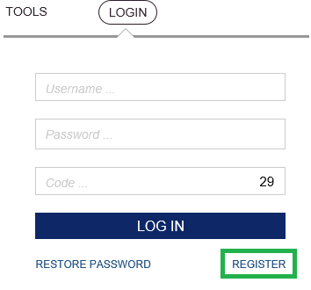
- Registration form is opened.
Information fields/buttons marked with an asterisk (*) are mandatory
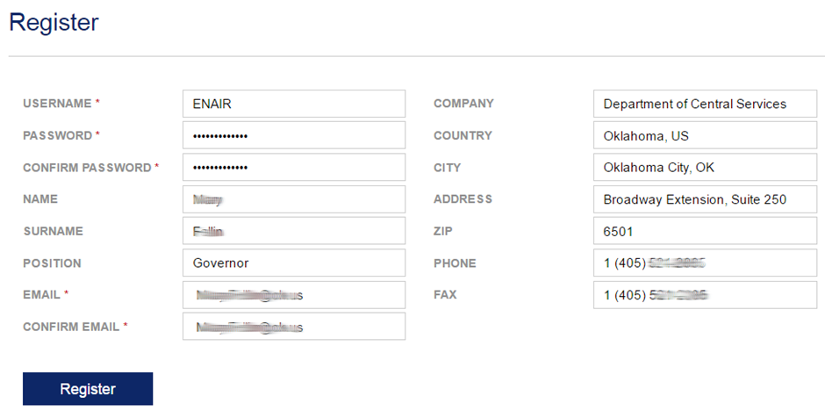

- When all fields in the form are filled in click on Register.
The user can log in and start using Data distribution tool and Data/information submission tool upon reception of approval by the AIS staff and after the approval, website’s server will send an e-mail with automatically generated code-key table. The code-key table is a set of 36 numbers (each number contains 6 digits) that the user receives via e-mail after the confirmation of registration.
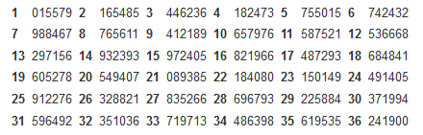
(Code-key table example)

Login
In order to start using Data/information submission tool or Data distribution tool:
- Go to https://ais.lgs.lv
- Click on LOGIN
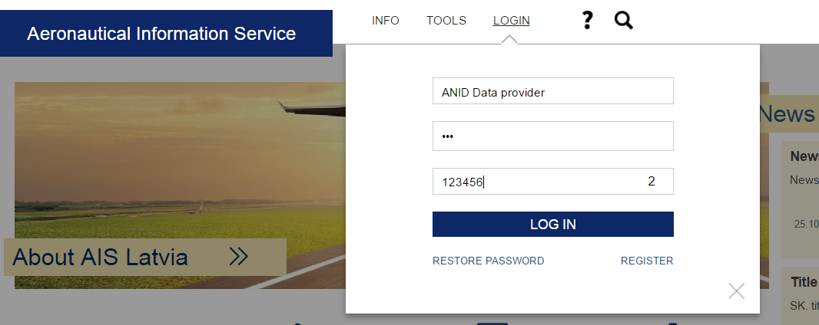
- Upper field: input user name
- Middle field: input password
- Lower field: input access code from the code-key table according to the displayed number

- Click on LOG IN
- Select tool
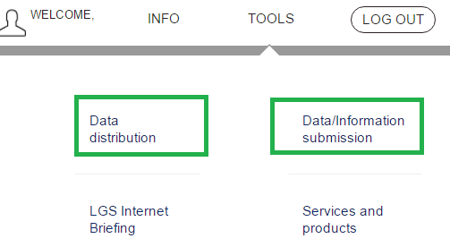

File exchange and CRC32Q value with/without JAVA APPLET

Managing JAVA Applet option in USER PROFILE
File exchange with/without JAVA applet can be managed through settings in User profile.
- After you have logged into the system, click on user icon where “Welcome user name” is displayed on menu.
- System opens User profile. Actual status for JAVA applet use for file exchange is displayed in profile form FILE EXCHANGE WITHOUT JAVA - YES or NO.
- In order to change settings that will remain valid for next working sessions, click on Edit profile.
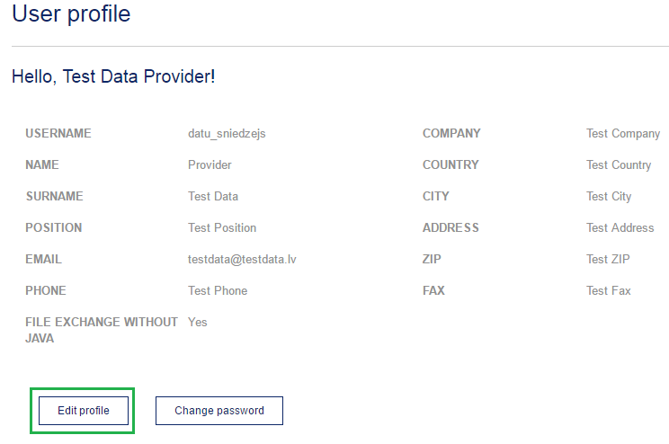
- System opens User profile form in editing mode. In the section FILE EXCHANGE use radio button to enable or disable file exchange without JAVA applet. And Submit.
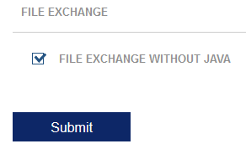
These settings will be valid for file exchange in future working sessions.

File exchange without JAVA
In order to submit information and add files to a request on a regular basis as provided by your browser, i.e., without JAVA support, use the checkbox File exchange without JAVA to disabled JAVA.
- Click Add file.
- Select a file in browser’s window Open and click Open.
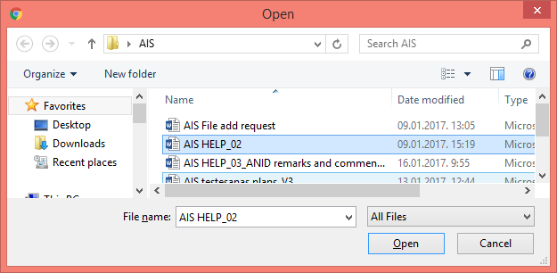
- Selected file will be added to the request and displayed in section ATTACHED FILES.
Please note that in this case CRC32Q value will not be calculated automatically and it is your responsibility to provide a CRC32Q value of the file that you wish to add.
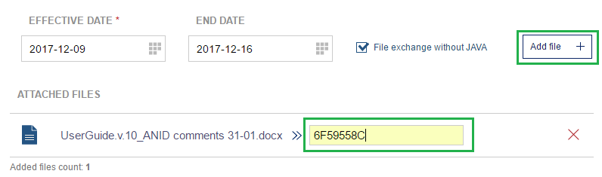
- In order to save added information click SUBMIT.
Names of all added files are displayed in the request form in section ATTACHED FILES.
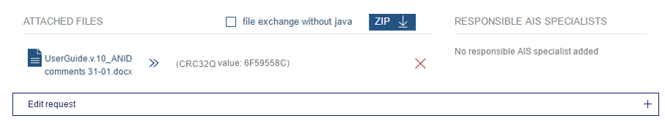

File exchange with JAVA
If you wish to submit files using JAVA applet support (that automatically generates CRC32Q values for submitted files), checkbox File exchange without JAVA should be disabled.
Please note that if you wish to use JAVA applet, Java Runtime Environment should be installed on your PC and JAVA plugin in the web browser should be supported and allowed to run.
In this case clicking on Add file will result in system alert:
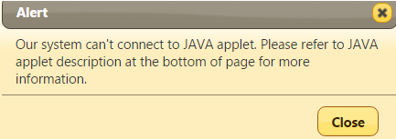
User should follow the installation instructions for JAVA applet for file upload and download.
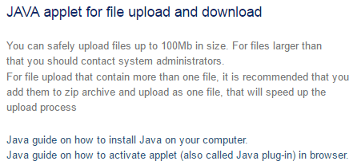
The following file upload or downolad is done using JAVA applet and verification of file’s CRC32Q value is done automatically.

JAVA applet upload in Microsoft INTERNET EXPLORER
In this case clicking on Add file will result in system alert:
- An option to Run JAVA will be displayed at the bottom of page. Please, note that also Java Runtime Environment may have version updates.
- In such case choose Update, if you wish to update your Java Runtime Environment, or choose Run this time, if update is not desired.
- In the next step approve JAVA applet by clicking Run.
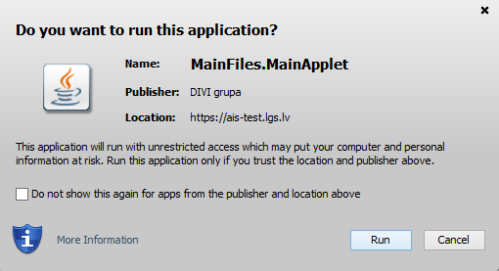
- Information “JAVA applet is running!” will be displayed below the request form in the section for JAVA applet instructions.
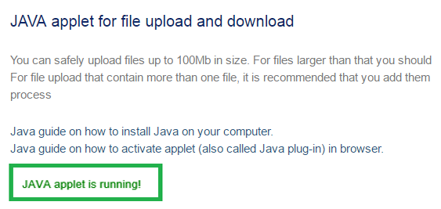

JAVA applet upload in mozilla Firefox
! Please note that since version 52 Firefox do not longer support Java applets.
If you have older Firefox version, in this case clicking on Add file will result in system alert:
- An option to Run JAVA will be displayed below the browser’s address line. Please, note that also Java Runtime Environment may have version updates. Click on Allow http://ais.lgs.lv to run Java.
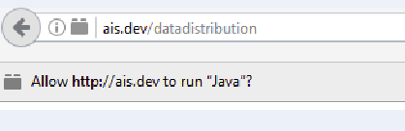
- In the next step choose Allow Now, if you wish to use JAVA just for this session, or click on Allow and remember for to save JAVA settings for next sessions.
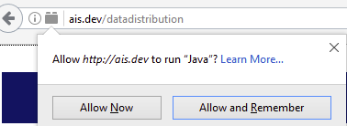

Checking FILE CRC32Q value when JAVA disabled

Via actions: Check file CRC32Q value
Check file CRC32Q value command provides the user with the option to check correctness and content similarity of the submitted file to the original file on the user’s PC.
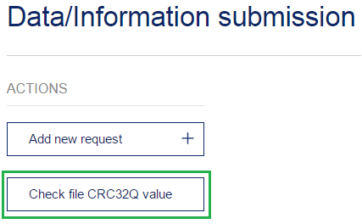
File CRC32Q value has to be entered into field INPUT CRC32Q value.
Click on Add file and choose an original file on your PC .
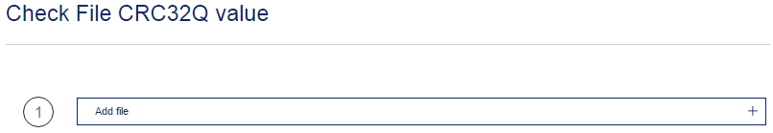
System displays file CRC32Q values of the file that has been uploaded to server.
In column Status results of CRC32Q values comparison are displayed:
- If file CRC32Q values do not match
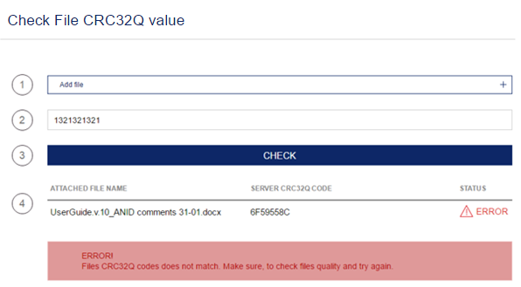
- If file CRC32Q do match

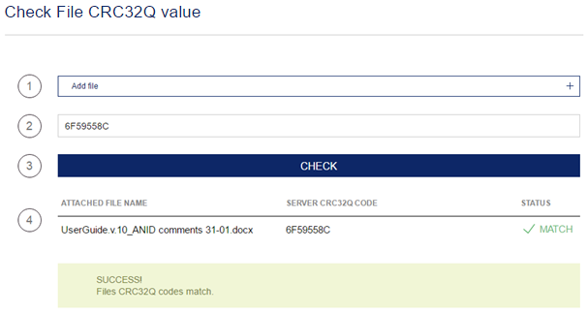
If a browser on your PC does not support JAVA plugins (e.g. Chrome), CRC32Q value check can be done manually after downloading specified program CRC32Q checker.

Via CRC32Q value checker program
The user can check file’s CRC32Q value of the requests and files that have already been submitted while requests are in the submitted status.
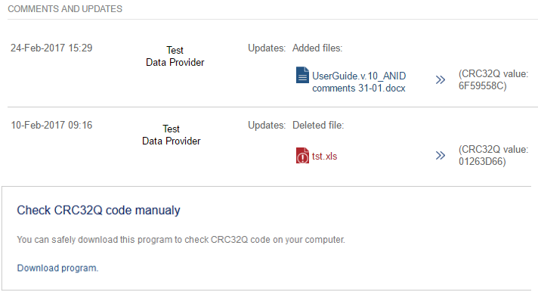
Following the further instructions the user can check file’s CRC32Q value choosing a file on your local PC and clicking on Select file to check CRC32Q.
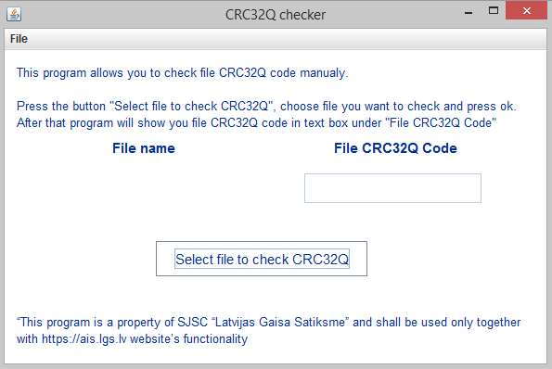

Data/information submisstion tool
Data/Information Submission Tool has two main groups of functionality:
- Actions: Add new request and Check the file’s CRC32Q value
- Filters: setting filters in order to search for registered requests

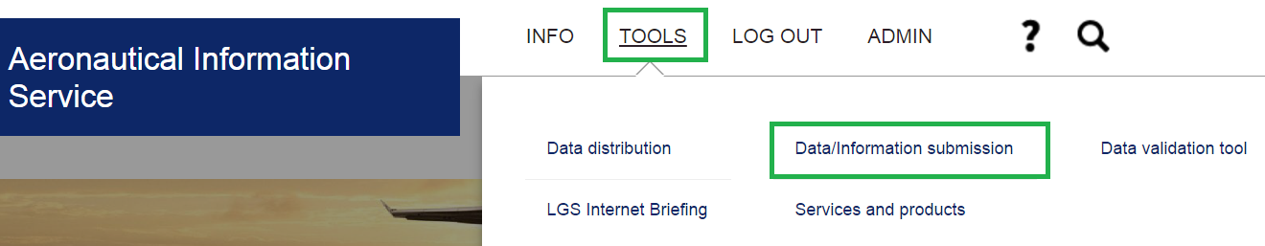
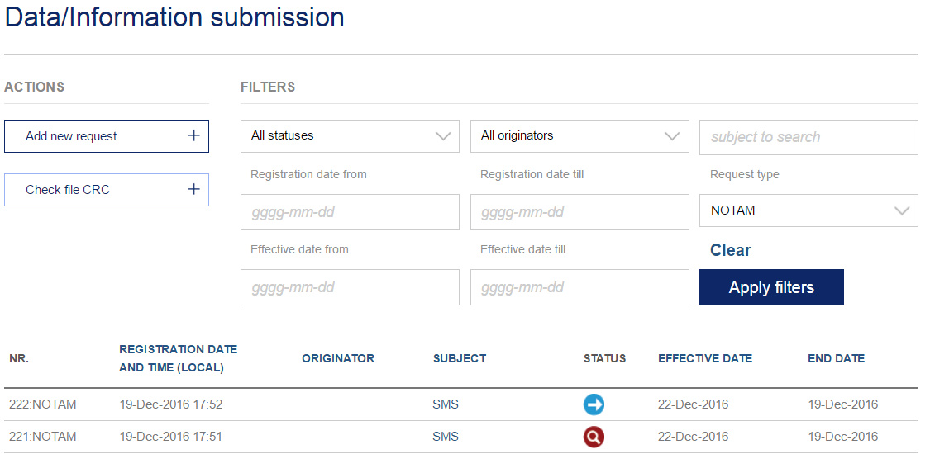

Actions: Add new request
In Data/Information submission tool, section Actions, click on Add new request.
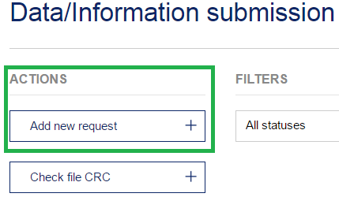
System opens a form for information input (by default for AIP AMDT request type).
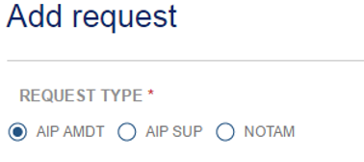
User should specify type of request: AIP AMDT, AIP SUP, AIC or NOTAM. Data/information submission form is specific for each request type.

Data submisstion for request types: AIP AMDT, AIP SUP AND AIC
Information input fields/buttons marked with an asterisk (*) are mandatory.
Input field | Description
Subject | Short description or a name of particular request.
Text | AIP content that should be published.
Explanation | Supplementary information about submitted data, explanation of request intents.
Effective date | Desired date of publication of submitted information.
End date | Desired date of information withdrawal from publication.
File exchange without JAVA | Please refer to chapter 3 “File exchange and CRC32Q value with/without JAVA applet”
Add file | Give possibility to attach a file to the request.
Attached files | Section displays files that have been attached to the request.
Responsible AIS specialists | AIS specialists that are assigned to assess the submitted request (this field will appear in process of the request evaluation).
Is this information operationally significant? | User at own discretion uses radio buttons Yes and No to provide insight if provided information is operationally significant.  If Yes is checked, system will ask if NOTAM is required  Please check respective radio button.
METADATA INFO FIELDS | Fields to provide information on data source and interaction in order to ensure data traceability and Commission Regulation (EU) No 73/2010 requirements.
! For submitting the information to be published by AIC, please choose Request Type – AIP AMDT.
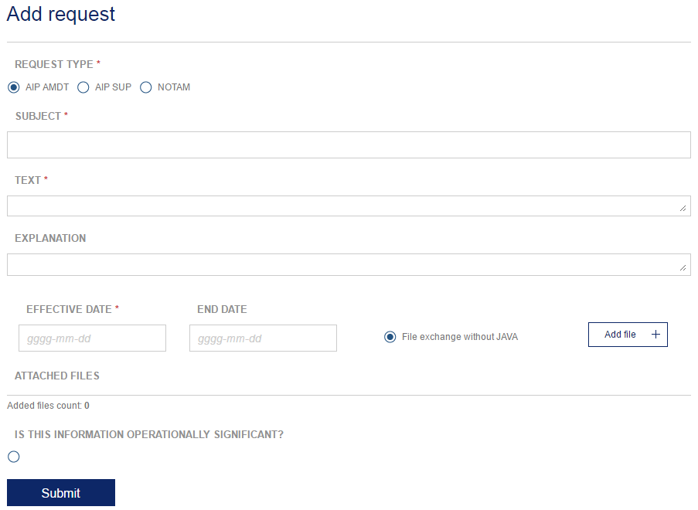
In order to submit a filled in request form the user clicks on Submit. Herewith the request is submitted and has been assigned status SUBMITTED.

Data submisstion for Notam request type
Information input fields/buttons marked with an asterisk (*) are mandatory.

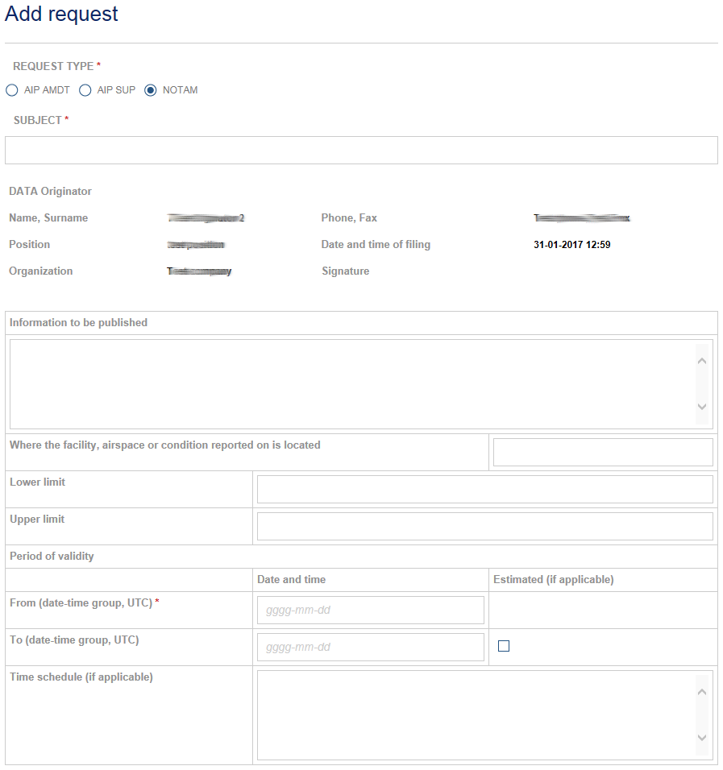
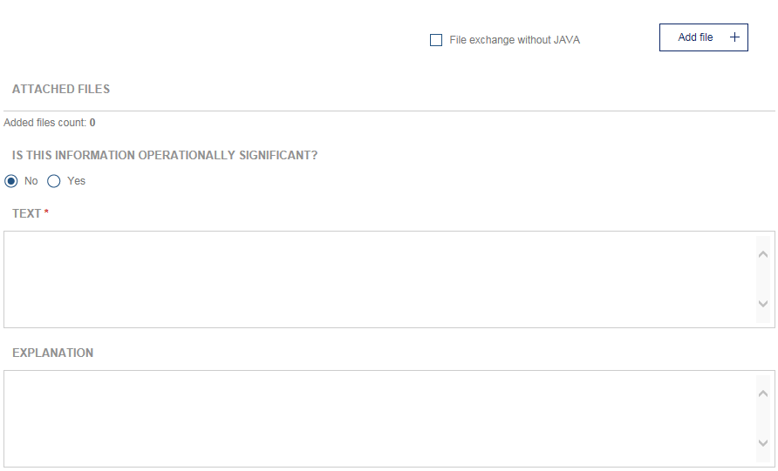

Input field | Description
Subject | Short description or a name of particular request.
Data originator | Non-editable field displaying registered information about data provider: Name, Surname, Phone, Position, Company, Fax
Information to be published | NOTAM content that should be published.
Where the facility, airspace or condition reported on is located | Location of reported facility, airspace or condition.
Lower limit  (for Navigation Warnings only) | LOWER limit shall contain an altitude (Above Mean Sea Level – AMSL) or a height (Above Ground or Sea or Surface Level – AGL) expressed in metres or feet, or a Flight Level (always expressed in 3 digits). In addition, SFC and GND shall be used to designate surface and ground respectively.
Upper limit  (for Navigation Warnings only) | UPPER limit shall contain an altitude (Above Mean Sea Level – AMSL) or a height (Above Ground or Sea or Surface Level – AGL) expressed in metres or feet, or a Flight Level (always expressed in 3 digits). In addition, UNL shall be used to designate unlimited.
From (date-time group, UTC) | A ten-digit date-time group giving the year, month, day, hour and minute at which the NOTAM comes into force
Estimated (if applicable) | Check radio button, For NOTAM of uncertain duration of validity (the date-time group shall be followed by ‘EST’ (estimate)).
To (date-time group, UTC) | End date of request validity period
Time schedule (if applicable) | Please provide time schedule if it is applicable
File exchange without JAVA | Please refer to chapter 3 “File exchange and CRC32Q value with/without JAVA applet”.
Add file | Give possibility to attach a file to the request.
Attached files | Section displays files that have been attached to the request
Responsible AIS specialists | AIS specialists that are assigned to assess the submitted request (this field will appear in process of the request evaluation).
Is this information operationally significant? | User at own discretion uses radio buttons Yes and No to provide insight if provided information is operationally significant.
METADATA INFO FIELDS | Fields to provide data that provide information on data source and interaction in order to ensure data traceability and Commission Regulation (EU) No 73/2010 requirements.

To submit a filled in request form the user clicks on Submit. Herewith the request is submitted and has been assigned status SUBMITTED.

Metadata submission for all request types
In prior to submit a request, user feel in METADATA fields to provide data that provide information on data source and interaction in order to ensure data traceability and Commission Regulation (EU) No 73/2010 requirements.

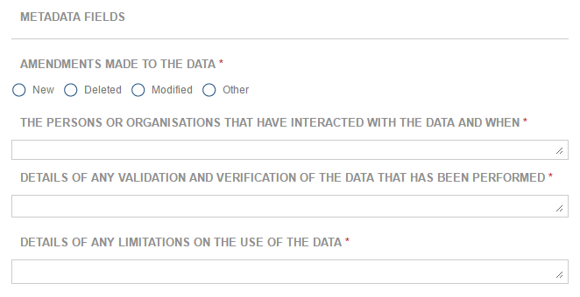

Request processing statuses
Request status | Description | Options for Data Originator
 |  | Edit and add files | Delete | Change status | View only, download
Submitted | Data originator submits a request to AIS via data/information submission tool.  Data originator can edit the request and change status to DELETED BY THE DATA ORIGINATOR
Under Assessment | AIP administrator or NOTAM administrator processes the submitted request and performs assessment of provided information. | - | - | -
Info requested | AIP administrator or NOTAM administrator may ask for additional information that should be provided by data originator. After requested information is submitted, status is changed to SUBMITTED. |  |  |  | -
Cancelled | A request can be cancelled by the AIP administrator due to assessment results or data originator’s failure to submit requested information. | - | - | -
Deleted by data originator | Data originator can delete submitted request thus withdrawing the request from further assessment process.  Can be deleted if the request is in the status SUBMITTED | - |  | -
Postponed | Assessment of a request can be postponed by the AIP administrator |  | - | - | -
Approved | Assessment has been finished and administrator has approved a request. Approved requests proceed to verification requested by the AIP administrator. | - | - | -
Verification | AIP administrator provides a proposal for publication that should be verified by data originator. | - | -
Not verified | Data originator has denied a draft for publication that was made by AIP administrator. Repeated verification should be requested by the AIP administrator. | - | -
Verified | Data originator has verified draft for publication. The request can be published by the AIP administrator | - | - |  | -
Published | Approved and verified requests are published in AIP. | - | - | -
Closed | Request validity date expires is removed from Data distribution tool’s list of published requests. | - | - | -

Request change history
Section COMMENTS AND UPDATES displays history of all actions performed to the registered requests, e.g. change in status, updates, comments added by data originator or AIS specialist.
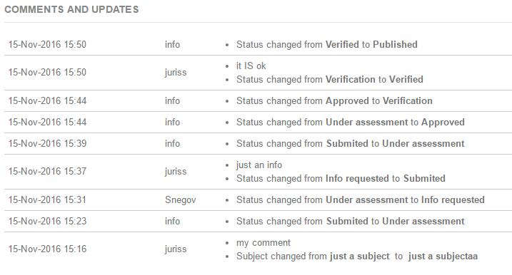

Search registered requests
All previously submitted requests/ information are shown in the table specifying Number, Registration date, Originator, Subject, Status, Effective date, End date. The search of registered requests can be performed by using the following filters:
- Status | - Originator | - Request type
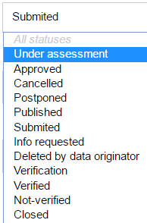 |  | 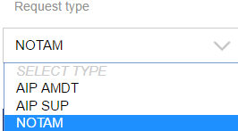

- Registration date from; Registration date till | - Effective date from; Effective date till
When filtering parameters are set, click Apply filters.
Press Clear to remove all filters.

Open the registered request by double-clicking on the request’s subject.

Edit AIP AMDT, AIP SUP AND AIC registered requests
Select registered AIP AMD, AIP SUP and AIC requests by using filters. Find the request and double-click on request’s subject.
! Only requests that are in SUBMITTED or INFO REQUESTED status can be edited by the data originator.

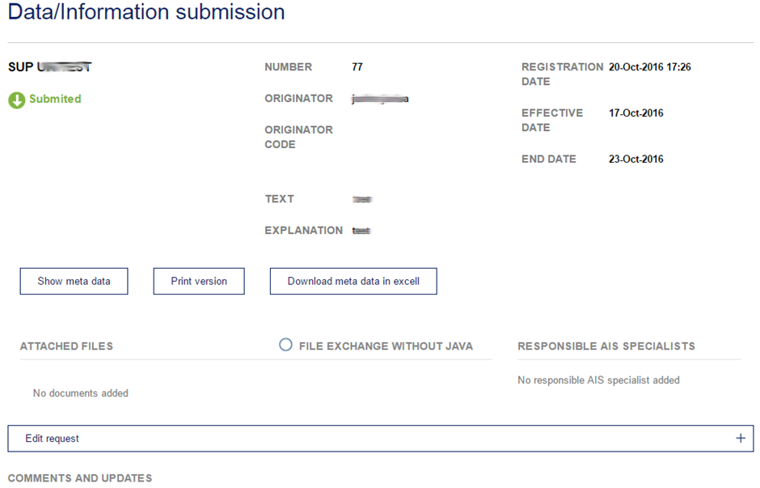
Request subject and status symbol is displayed in the left upper corner.
Available commands | Description
Show/Hide metadata | Command to show or hide meta data in a request form.
Print version | A request form is shown in printer friendly A4 format.
Download meta data in Excel | System generates Excel file containing the meta data provided in a request.
File exchange without JAVA | Please refer to chapter 3 “File exchange and CRC32Q value with/without JAVA applet”.
Download ZIP | Downloads a compressed ("zipped") archive file that contains all files attached to this request.
Edit request | Data originator can open a request form. Editing options are provided according to the request’s status. Please refer to section 4.1.4 “Request processing statuses” to check the request statuses that allow data originator to edit the request.  Only requests in status SUBMITTED, INFO REQUESTED and POSTPONED can be opened for editing.

Data distribution tool
AIS website’s section DATA DISTRIBUTION TOOL contains published information and provide a possibility to download and check the integrity of downloaded files on the end user’s PC.
In order to use Data distribution tool AIS clients have to subscribe to this information by specifying to which published information they would like to have access and reporting this to the office of AIS of Latvia.
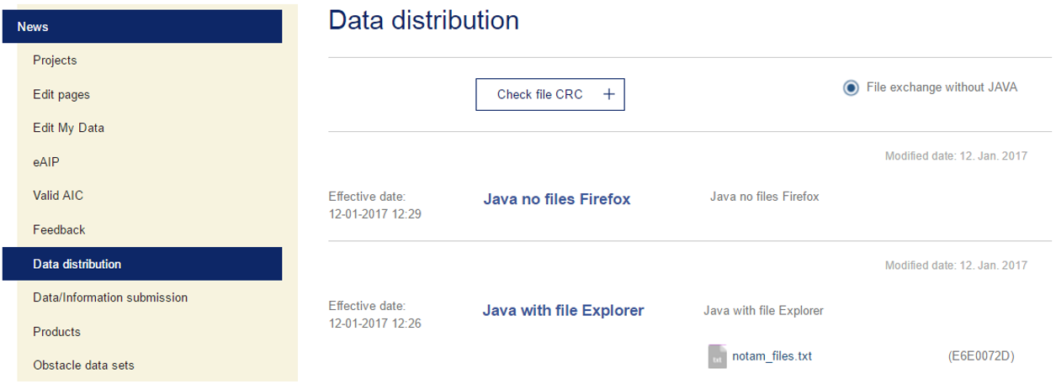
Subscribers can read the published information, download files and check file CRC32Q value.

File Download from Data distribution tool

File download without JAVA
- In order to download files without JAVA, option File exchange without JAVA should be enabled.
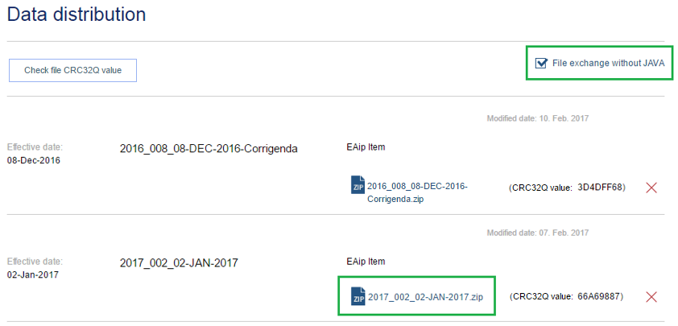
- Clicking on the file name will result in instant downloading.
- Clicking on the file at download section of your browser will result in opening a file.
In order to check CRC32Q value of the downloaded file follow the instructions:
- Click on Check File CRC32Q value
- Click on Add file in the line number 1
- Select a file. The file name is displayed in the line number 4 – Attached file name
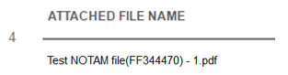
- Enter downloaded file’s CRC32Q value in the line number 2
- Click on Check in the line number 3
Below are examples of file CRC32Q value check:
- when CRC32Q values do not match
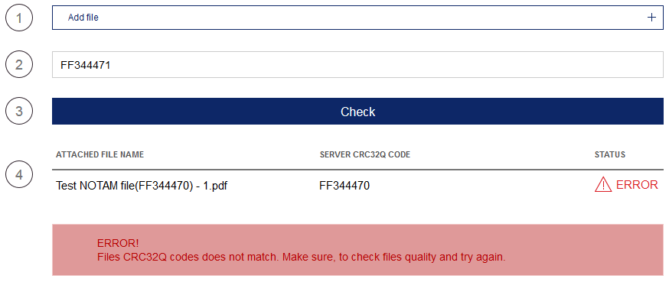
- when CRC32Q values do match
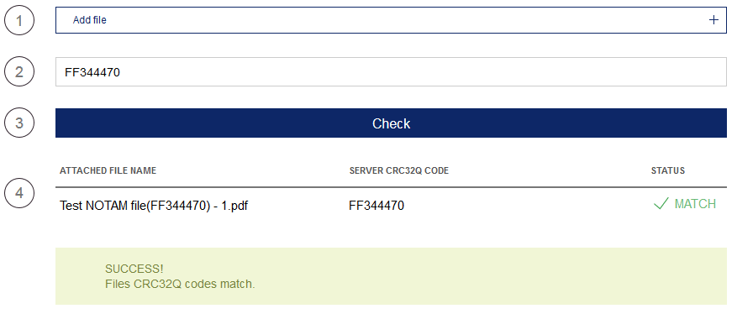

File download with JAVA
- In order to download files with JAVA, option File exchange without JAVA should be disabled.
- In this case clicking on the file name will result in system’s alert.
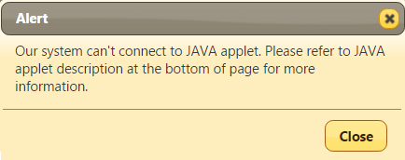
- User should follow the instructions on installing JAVA applet according to the active Internet browser on your PC as described in section 3.3 File exchange with JAVA.

